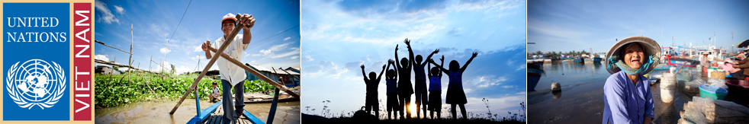
Information sharing session on humanitarian funding mechanisms

Date: Thursday 30th August 2012
Time: 2-4pm
Venue: NGO Resource Center meeting room, La Thanh Hotel, 218 Doi Can, Hanoi
Participants: DMWG, UN DRMT, UN OCHA, GoV, donors

Tentative agenda:
- Agenda presentation (10’)
- Presentation on humanitarian funding mechanism: OCHA cash grant, CERF, Flash Appeal, etc. (UN OCHA) (30’)
- Presentation on humanitarian funding mechanism: UNDP early recovery grant (UNDP) (15’)
- Sharing of INGO experiences with UN funding mechanism (by Save the Children, CARE, Habitat for Humanity, e.a.) (20’)
- Q&A (45’)

Please RSVP to Ms. Bui Viet Hien (UNDP), bui.viet.hien@undp.org by cob Tuesday 28th August

