

Agreement for Performance of Work between ____________ and UNAIDS

TERMS OF REFERENCE

HEALTH ECONOMIST CONSULTANT TO SUPPORT THE DEVELOPMENT OF A TRANSITION PLAN

I. B A C K G R O U N D

Since the first case of HIV was detected in 1990, Viet Nam has made significant strides in addressing the HIV/AIDS epidemic. International donors have been an important stakeholder in the response to the national epidemic. According to the National AIDS spending Assessment (NASA), international sources contributed 72.5% of total AIDS resources in the period of 2008 – 2010. Prevention, treatment and care were heavily financed by international sources, which provided 79% of total prevention resources and 56% of total treatment and care funds. On the other hand, the Government budget only paid for 12% of prevention costs and 7% of treatment and care costs, while 37% of treatment and care costs and 9% of prevention were covered by household out-of-pocket payments.

Following Viet Nam’s recent achievement of lower-middle income status in 2010, donors have begun to reduce their funding for HIV/AIDS service delivery and shift to a role of technical assistance. This reduction in support, combined with the current global financial context, is posing important threats to the sustainability of the response to the HIV/AIDS epidemic in Viet Nam. Indeed, an analysis of long term financing options undertaken by the Vietnam Authority for AIDS Control (VAAC) with support from UNAIDS , revealed a major gap between domestic resources available and those needed to address the epidemic in the near future (Figure 1). There is thus a critical need to understand how HIV/AIDS prevention, care and treatment programs can be maintained in a manner that will continue to have sustained impacts on the epidemic.

Figure 1: Anticipated funding 2013-2020

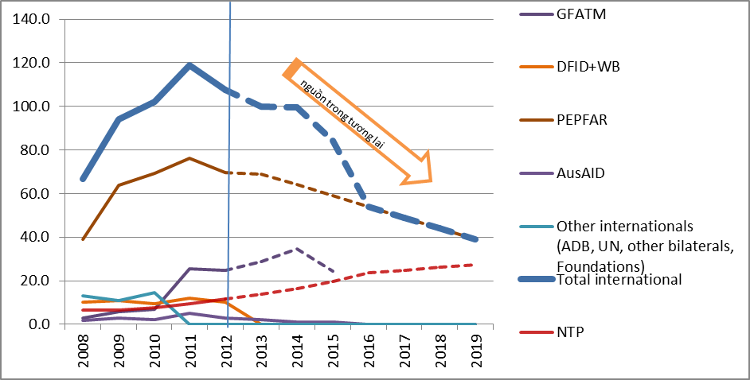

The transitioning of large-scale donor funded service delivery programs to the goverment, as is to be done in Viet Nam, has not been well-documented elsewhere. To ensure smooth transitioning of programs, careful and evidence-based planning among all stakeholders is essential. Analysis will need to be done on how limited financial resources can be allocated more effectively and efficiently, and a package of prevention, care and treatment services that will be delivered under the government program following transition of donor programs defined. These key outputs will serve to inform the development of a national ‘Transition Plan’, which will outline the technical, financial, and human resource needs at each phase of the transition. To this end, a health economist consultant is being sought to support VAAC in development of the transition plan, with other development partners working in HIV/AIDS programming in Viet Nam – namely PEPFAR, Global Fund, Wolrd Bank, DFID, and AusAID etc..

II. PURPOSE

The overall objective of the consultancy is to support the preparation of a smooth transition plan as the Government of Vietnam takes over programmes due to reduced direct programme funding by development partners.

The consultant is to support VAAC in their coordination with development partners to draft and finalise a detailed transition plan that will outline how VAAC is to gradually take over the management of programs, and the needs at each stage of the transition. More specifically, as a health economist, the consultant will analyze how cost norms of various donors can be harmonized into one service package, how management of structures can be optimized, and how efficiency gains can be achieved in service delivery in order to ensure that a continuum of prevention, treatment and care services is maintained.

iii. scope of Work

The health economist consultant will conduct the following tasks for VAAC:

- Provide technical support to identify areas for efficiency gains, by reviewing packages, structures, processes and management practices so as to allow efficient programming in geographically priortised areas, based on local evidence and using best practices from the region.
- Provide support in harmonizing different cost norms while devising a scheme that enables smooth transition in having uniform programmes and cost norms that can be easily sustained with domestic funding.
- Calculate unit costing of the packages of services and support evidence informed decision making for priortisation of the program and allocating resources, and revise / draft the national resource needs estimation.

iV. Time frame

- Duration of assignment: 40 working days , from 31 May to 31 July 2013
- Duty station: VAAC Hanoi, with travel to provinces when required.

V. deliverables

- Consultancy report on suggested ways for harmonizing cost norms across programmes and encouraging cascade of prevention through treatment and care services.
- Report suggesting efficiency gain opportunities and providing scenarios of response scale up using available funding.

Vi. BUDGET

Consultancy rate:

Payment terms:

- 25% of the total amount of the contract upon signature of the contract.
- 75% of total contract value on submission of final deliverables, satisfactory completion of all work and delivery of all deliverables.

Vii. Guidance & Monitoring

- The successful candidate/s will work closely with VAAC and under the overall guidance of Deputy Director VAAC for the M&E division, entrusted with the task of developing a transition plan.
- Consultant/s will regularly report on technical and operational matters to UNAIDS Senior Adviser on Policy and Strategy .

VIII. PROFILE OF THE CONTRACTUAL PARTNER

The consultant/s should meet the following requirements and qualifications:
- University post-graduate level in health economics, or a relevant related field; preferably PhD.
- At least eight (8) years of professional experience;
- Familiarity with tools like AEM, GOALS, resource need estimation, costing of packages is desirable.
- Demonstrated understanding of the national AIDS program, organizational structure and financial system of Viet Nam;
- Demonstrate good knowledge and experience using tools and methodologies for analyzing financial data. Familiarity with the Vietnamese context is a prerequisite;
- Excellent analytical skills;
- Excellent verbal and written communication skills.
- Report writing, editing skills.

