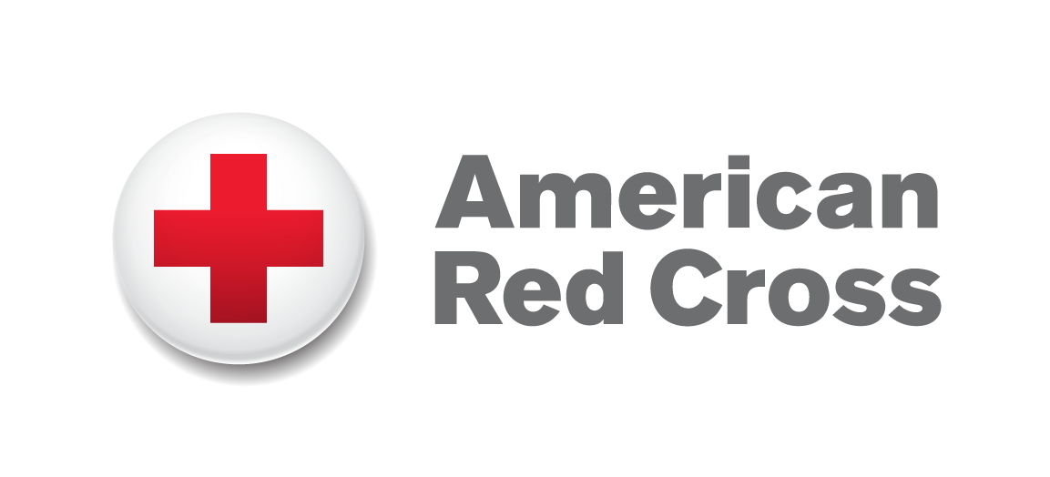
Program Officer, HIV Prevention, Care and Support

Summary:
The American Red Cross (ARC) Vietnam Delegation seeks an experienced and enthusiastic Program Officer to assist in the management of an HIV Prevention, Care and Support project implemented by the Vietnam Red Cross with technical and financial support from the American Red Cross. The project, in its fifth year of implementation, targets PLHIV, their partners and families, and high-risk groups, such as sex workers (SWs), men who have sex with men (MSM), people who inject drugs (PWID), migrant workers and youth in Hanoi, Hai Phong, Thai Nguyen and Son La. Project sites in central Vietnam may be added in the future. This is a full time position based in Hanoi with frequent travel within Vietnam. The Program Officer reports to the Senior Program Officer.

Responsibilities:
- Provide technical support to the Vietnam Red Cross (VNRC) and other key partners.
- Assure program quality and timely achievement of program deliverables.
- Conduct frequent monitoring visits in support of program activities.
- Participate in various working groups/technical meetings and share information with team members.
- Assist in developing and tracking project budgets.
- Perform logistical and supporting functions including event, meeting and training coordination.
- Foster an effective working relationship with American Red Cross partners, the Vietnam Red Cross and provincial Vietnam Red Cross branches.
- Prepare consolidated ARC monthly and quarterly reports, monitoring reports and meeting minutes to the donor and partners as required.
- Liaise, network and conduct research with local and international organizations, both governmental and non-governmental.
- Provide support for new program and funding opportunities in accordance with the American Red Cross and Vietnam Red Cross strategic plans.

Qualifications:

- Bachelor’s degree in relevant field, Master’s degree/advanced degree preferred
- Minimum 3 years work experience in HIV/AIDS prevention, care and support programs in Vietnam including at least 2 years with INGOs
- Experience working or collaborating with Red Cross and/or mass organizations preferred
- Experience studying or working in other countries preferred
- Experience in program management including program design, training, implementation, monitoring, and report writing
- Fluent in written and spoken English and Vietnamese
- Ability to travel up to 50% of time to project sites
- Advanced skills in Microsoft Office such as Word, Excel, PowerPoint, and Access.

Applicants should send a current resume and a cover letter containing the name and contact details of three references as well an indication of salary expectations to amcrossvn@hotmail.com by 17:00 31 May 2013. Use “Application for HIV Prevention, Care and Support Program Officer” in the subject heading of your email.

Only qualified candidates will be contacted.
The American Red Cross is an Equal Opportunity/Affirmative Action Employer

