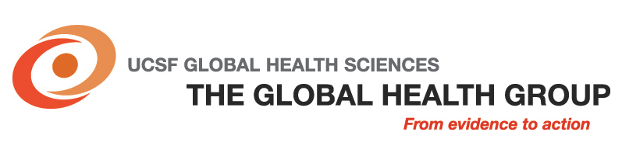

UCSF Global Health Group
Malaria Elimination Initiative Project Manager in Vietnam

Independent Consultant Position Description

The Global Health Group at the University of California, San Francisco (UCSF) is an “action tank” dedicated to identifying, elaborating and translating innovative solutions to major global health challenges into large-scale action to advance health and save lives in low- and middle-income countries. Organizationally, the Global Health Group is a component of UCSF Global Health Sciences.

The Malaria Elimination Initiative
The Global Health Group’s Malaria Elimination Initiative (MEI) provides intellectual and practical leadership and support for the elimination of malaria, working from the global margins of the endemic zone inwards. The MEI works with a wide range of partners to gather, analyze and disseminate country and regional evidence on malaria elimination, to inform country and global decision-making. The MEI supports the design and implementation of malaria elimination programs in six countries in the Asia Pacific and southern Africa. MEI conducts operational research around diagnosis and surveillance in using the most effective and efficient techniques to eliminate malaria. The MEI is funded through grants from the Bill & Melinda Gates Foundation and the US Navy.

BAA Navy Proposal: Restratification of epidemiology and development of interventions for more effective control and elimination of malaria in Vietnam.
The UCSF Global Health Group’s Malaria Elimination Initiative (MEI), received a US Navy Advanced Medical Development funding to support: 1) Enhanced Surveillance and Operations Research for Malaria Control and Elimination in Areas of Emerging Artemisinin-Resistance, and 2) Protection of Remaining Malaria Prophylaxis Drugs in Cambodia and Vietnam. The Navy Medical Research Command-Asia and UCSF Global Health Group harmonized the funded proposals with the objectives of Vietnam’s National Institute of Malariology, Parasitology and Entomology (NIMPE) for the project entitled “Restratification of epidemiology and development of interventions for more effective control and elimination of malaria in Vietnam.” This project is comprised of two main objectives: 1) identify malaria epidemiology with different levels of endemicity and populations at risk to allow more effective application of limited resources, and 2) develop appropriate strategies and associated targeted interventions in order to plan and execute more effective control and elimination of malaria for specific areas. These objectives will be realized through three main activities: 1) update and optimize the malaria surveillance system with the introduction of a Spatial Decision Support System (SDSS) to support targeted interventions and the monitoring and evaluation of their impact; 2) maximize the impact of interventions through operations research to model the potential impact of all currently available and emerging interventions; and 3) quality improvement of current tools for malaria elimination by improving diagnosis, treatment and the implementation of individual case reporting.

The Malaria Elimination Initiative Consultant, Project Manager
Work closely with National Institute of Malariology, Parasitology and Entomology (NIMPE) and Military Institute of Hygiene and Epidemiology and report to the MEI Deputy Lead for Surveillance and Operations Research, the Malaria Elimination Initiative Project Manager will be responsible for high-level management and coordination of project activities in Vietnam.

Duties
- Liaise with multiple project team members, US and Vietnamese government representatives, the Vietnamese military and NGO partners to ensure timely completion of tasks and accomplishment of project objectives
- Develop and monitor work plans and timelines
- Disburse, track and manage project funds
- Coordinate project team meetings
- Support project logistics
- Build relationships with project stakeholders
- Prepare regular progress reports to the US Navy, the Stakeholder Committee, and other project partners as appropriate
- Assist the US-based Program Manager to: (a) prepare and negotiate institutional MOUs, contracts and consultant agreements; (b) manage project finances, and (c) identify and pursue grant applications for further funding
- Contribute to the scientific mission of the project by: (a) compiling literature reviews and conducting expert interviews to optimize planned interventions, (b) developing support manuals/SOPs, and (c) coordinating and contributing to academic publications and presentations.

Qualifications and Competencies
Essential
- Proven ability to manage complex projects
- MD, PhD, MPH and/or MBA (or equivalent experience)
- Bilingual in Vietnamese and English (spoken and written)
- Excellent leadership, organizational and administrative skills
Desirable
- Background in malaria or other infectious disease control and elimination
- Background in clinical research trials and quality assurance methodology
- Experience executing projects in rural Vietnam
- Proficiency with Microsoft Word and Excel and web-based systems

This is a 100% time consultant position, currently funded through April 31, 2015. Further extension is desired, but is dependent on receipt of additional funding and performance. The Project Manager will be based in Hanoi. Domestic and international travel of 10 days’ duration will be required. Immediate start date highly desirable.
Salary
Salary is negotiable. Payment is contingent upon the number of days consultant has worked and will generally be 20 days per month. The consultant should keep a precise spreadsheet of time spent on the project and will invoice monthly.
Applications
Candidates seeking to engage as a full time independent consultant, please send your resume and cover letter to nguyenhien470@gmail.com

Closing date: May 9, 2014.

