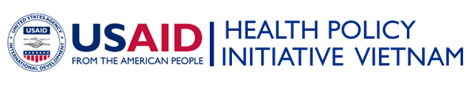 | 

Job opportunities

Program Officer position

Health Policy Initiative Vietnam, Ho Chi Minh City Office

Health Policy Initiative Vietnam (HPI Vietnam) is a five-year project funded by USAID/PEPFAR and implemented by Abt Associates. HPI is designed to assist the collaborative efforts of the Government of Vietnam, U.S. Government, civil society organizations (CSOs), and other stakeholders to develop and implement evidence-based and best practice-driven laws, policies, plans, and programs for HIV/AIDS prevention, care and treatment and impact mitigation in Vietnam. HPI Vietnam is seeking well qualified and experienced Vietnamese citizen to fill the Program Officer position in Ho Chi Minh City Office.

Job descriptions:

Major responsibilities for Program Officer are:
- Be the key Abt Associates staff managing HPI’s projects in An Giang province: 100% Condom use component, Prevention intervention component for people living with HIV/AIDS (Positive Prevention), and legal aid for people living with or affected by HIV/AIDS;
- Be the key Abt Associates staff managing HPI’s Prevention intervention component for female sexual partners of drug users in HCMC;
- Perform other relevant duties when required.

Selection Criteria:
- Bachelor Degree in Public Health, Medicine, Social Sciences or other relevant fields.
- At least 2 years of relevant professional experience on HIV/AIDS & public health.
- Strong experience in program implementation.
- Strong interpersonal skills and communication skills, initiative, and good judgment.
- Excellent writing, computer, management and organizational skills.
- Excellent written and oral communication skills in both Vietnamese and English.

Interest candidates for the above positions may submit written application in English together with updated curriculum vitae, and copies of available degrees to: thanh@abtvn.com or mail to Abt Associates Inc, 72 Xuan Dieu, Hanoi (Attention: Nguyen Le Thanh) before 5:00 PM, July 25, 2010.

Only short-listed candidates will be contacted for interview. Applications will not be returned. Please no telephone contact after submitting the application.

