EMPLOYMENT OPPORTUNITIES  IN PUBLIC HEALTH | 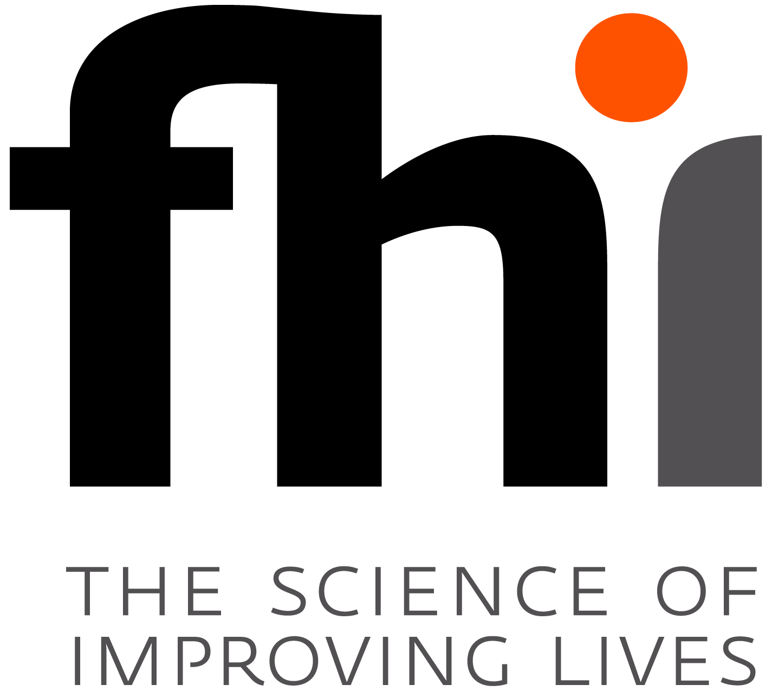
FAMILY HEALTH INTERNATIONAL (FHI) is an international non-governmental organization that works with the Vietnam Ministry of Health, other national ministries, provincial health services, and local non-governmental organizations to promote the health and well-being of the Vietnamese population, particularly among vulnerable and disenfranchised groups. FHI is currently building the capacity of local organizations in HIV/AIDS prevention, care, and treatment; in clinical research for the development of vaccines and drugs for infectious diseases; and in laboratory technical capabilities.
We are currently recruiting two experienced Vietnamese nationals for the following positions in Hanoi:
Program Officer – Care and Treatment, two positions
The Program Officer is responsible for developing, managing, and monitoring comprehensive HIV/AIDS care, support, and treatment projects supported by FHI, including antiretroviral therapy (ART). In addition, each of these positions will be a focal point person for one respective technical areas in (1) ARV treatment on people living with HIV (PLHIV) co-infected with TB and (2) Sexual and Reproductive Health (SRH) for PLHIV..
Successful candidates will have the following abilities and qualifications:
- Medical doctor preference for specialization in infectious diseases with knowledge of HIV clinical care and ARV treatment.
- Professional experience in providing medical care, preferably to PLHIV. Demonstrated skills and knowledge in holistic and client-centered care
- Knowledge and experience in epidemiology and/or STI clinical management in resource-poor settings would be advantageous
- Knowledge and experience in SRH and or TB/HIV is preferred but not required
- Minimum two years HIV/AIDS programming experience, preferably with INGOs
- Master’s degree in Public Health, Social Sciences, or related field, or equivalent years of experience an asset but not required
- Ability and enthusiasm to learn about new areas and willingness to contribute to a dynamic team
- Excellent written and oral communication skills in both Vietnamese and English
- Experience with computers, including word processing, spreadsheets, and the Internet
FHI offers competitive salary and benefits.
Please submit detailed curriculum vitae with cover letter (in English) clearly indicating the position you are applying for as well as copies of relevant certificates/degrees, by June 30, 2010 to:

Human Resources Officer, Family Health International
7th Floor, Hanoi Tourist Building, 18 Ly Thuong Kiet Street, Hoan Kiem District, Hanoi, Viet Nam

Email: recruitment@fhi.org.vn

To obtain a detailed job description for the position, please send your request to recruitment@fhi.org.vn. Only short listed candidates will be invited for interviews.

