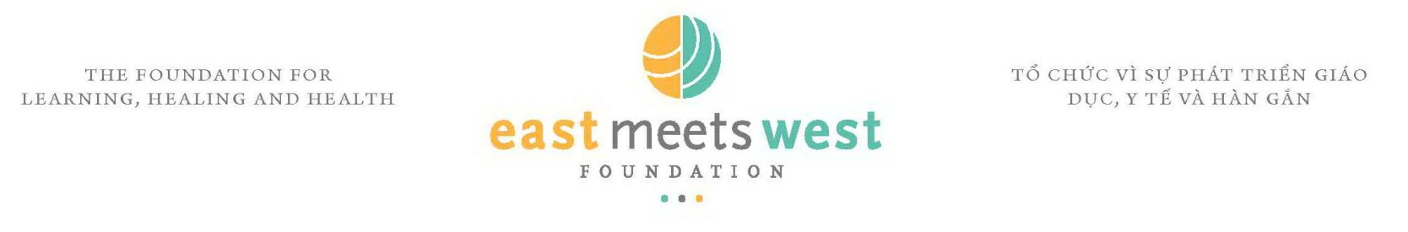
JOB ANNOUNCEMENT
Full Time Admintrative and Financial Intern based in Hanoi

Organizational and Program Overview:
The East Meets West Foundation (EMW) is “the foundation for learning, healing and health". Founded in 1988, EMW has a 23-year track record of innovative and effective work in Vietnam and a vast portfolio of completed projects. EMW projects and programs are known for their high quality, long-term sustainability, emphasis on results and significant scale.

EMW is looking for a full time Administrative and Financial (A&F) Intern based in Hanoi. The followings are the main duties and responsibilities for this position:

TASKS/RESPONSIBILITIES:

The full Time A&F Intern will perform a supportive role in covering administrative and financial work of EMW Hanoi office.

Report to: Office Manager, EMW Hanoi Office, Vietnam

Administrative works:

- Meet and greet guests to the office. Receive, sort and distribute incoming and outgoing mails to appropriate staff members in the office;
- Answer telephone calls, take messages and transfer calls to appropriate staff members. Provide back-up materials for call backs or make calls to external entities/Partners on Country Director’s or senior staff requests/notes;
- Make logistical arrangements for lodging, transportation, workshops/conferences, and for other projects and operational activities of the office;
- Ensure efficient filing, tracking and storing system of documents;
- Purchase and maintain office equipment and supplies with appropriate services and venders.
- Research and identify qualified suppliers for project related equipment and supplies;
- Translate office and project related documents (English and Vietnamese) when required;
- Other tasks if any to assist Office Manager to ensure smooth running of the office.

Financial works:

- Check Request for Payment based on invoice/bills from service providers
- Submit bank paperwork such as Application for Remittance if assigned
- Support in photocoping monthly financial paperwork and reports and any documents if requested.

DURATION:
This work will be definite for 6 months. The contract extension would be reviewed based on the actual needs.

REQUIRED QUALIFICATIONS:
- University graduate;
- Excellent command of Vietnamese (speaking and writing);
- Good knowledge of English (speaking and writing) and able to translate documents (English-Vietnamese);
- Good literacy with major computer applications;
- Working experience with international organizations or NGO(s) preferable.

The deadline for the above positions is April 25th, 2011. All interested candidates are welcome to contact and submit their applications to:

EAST MEETS WEST FOUNDATION
E-mail: thoi@eastmeetswest.org.vn and tonga@eastmeetswest.org.vn

