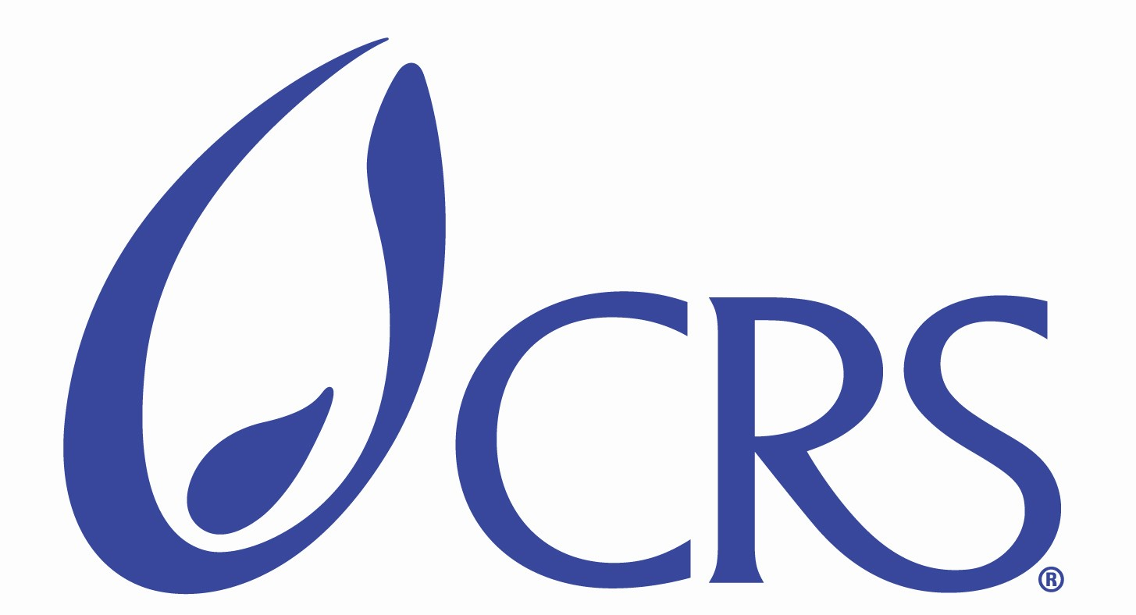

Catholic Relief Services

Post Announcement

Catholic Relief Services (CRS) is a US non-governmental organization that has been operating in Vietnam for more than 15 years. CRS projects assist local counterparts to build capacity in the areas of Education, HIV/AIDS, Emergency and Climate change. Reflecting our commitment to carry out quality programming to benefit the poor, we are now seeking dynamic Vietnamese candidates for two positions of UXO/Mine Education Project Officers based in Ha Noi.

Title: UXO/Mine Education Project Officer
Reports to: UXO/Mine Education Project Coordinator
Supervision: Not applicable
Project site: Quang Binh, Quang Tri and Quang Nam province

PRIMARY FUNCTION

Ensure effective implementation and oversight of “Strengthening Unexploded Ordnance (UXO)/Mine risk education in high risk communities” project in Quang Binh, Quang Tri and Quang Nam province. This position is based in Ha noi with estimated 40% travel to project sites in three provinces mentioned above.

KEY WORKING RELATIONSHIPS

Internal: Country Representative (CR)
Head of Programs (HOP)
Community Education Program Manager (PM)
UXO/Mine Education Project Coordinator
Community Education Program staff
Administrative and Finance staff

External: Provincial and district partners
International and Vietnamese NGOs and civil society organizations
Landmines working group members
Project consultants
Project donors as assigned by PM, Head of Programs and CR

SPECIFIC RESPONSIBILITIES

Programming
- Project Implementation: Participate in the planning and implementation of “Strengthening Unexploded Ordnance (UXO)/Mine risk education in high risk communities” with a focus on strengthening community outreach MRE and facilitating local partners’ in sustaining school-based MRE model. Provide support to the project team in implementation of MRE program activities.
- Project Quality Management: Support development of program quality and monitoring quality indicators. Maintain M&E system and feedback mechanisms between CRS and partners.
- Technical support: Support Project Coordinator in working with provincial education experts to define and pilot a sustainability plan for school-based MRE, which includes: development of teacher training manual, guidelines for mainstreaming MRE in school curriculum, designing tools for monitoring of school-based MRE. Support the work of CRS with provincial partners to strategize and implement a community engagement plan, with a focus on capacity building for and action planning/implementation by Community Outreach Teams and Parent’s Association at community level. Provide support to the design of tools to capture and document behavior change toward UXO/mine by at risk groups.
- Field Monitoring: Make regular field visits to project sites, meeting with project counterparts and participants to monitor quality or implementation of activities. Follow up the implementation and monitoring plan.
- Reporting: Provide regular recording, internal trip, activity reports and information for preparation of reports to donors, and others required by supervisor.
- Documentation: Participate in compiling lessons learned, designing and implementing events for exchange of program experience. Ensure effective recording and dissemination of results of all experience sharing activities. Contribute to designing system to compile and disseminate best practices within and outside CRS.
- Program Strategy Development: Contribute to strategic planning and program development within CRS/Vietnam.
Finance
- Financial Oversight: Provide support to project team in developing and monitoring annual program budgets. Maintain regular financial planning, review and adjustment.
- Financial Reporting: Cooperate with Finance team and partners to ensure effective tracking and reporting on budget expenses, to include financial reports, quarterly cash forecasts as required by supervisor.

Partnership, Advocacy and Networking
- Partner Relations: Maintain positive working relations with relevant government bodies, international organizations, civil society organizations and local partners.
- Networking and Advocacy: Maintain positive relations with partners and relevant organizations. Attend external meetings and networking activities related to mine action in general and MRE in particular at project sites and central levels. Facilitate partners’ efforts to advocate about the MRE program at regional and national level.
Other: Troubleshooting and other tasks as necessary, education program activities/projects as requested by supervisor.

Qualification and Personal Skills:

- University degree in fields relating to Education and/or Social Sciences
- At least three years professional experience, preferably with Vietnamese or international NGOs in the area of education and community development.
- Practical knowledge and experience with projects related to Mine Risk Education and/or Risk Reduction.
- Knowledge and practical experience in working with Education experts at different levels.
- Good organizational and computer skills (Word, Excel, Powerpoint, E-mail and Internet - required)
- Excellent spoken and written English
- Good communication and interpersonal skills
- Ability to work independently as well as in a team
- Availability to travel to project sites.

Application documents required:
- Curriculum Vitae in English, with names and addresses of three references
- Application Letter in English
- Copies of diplomas, certificates and relevant documents

Please send completed applications to:
Human Resources Manager, Catholic Relief Services, No 1 Alley 7, Nguyen Hong street, Ba Dinh District, Ha Noi.
Or email: Hong.dao@crs.org
Deadline for Applications: August 7, 2011.

