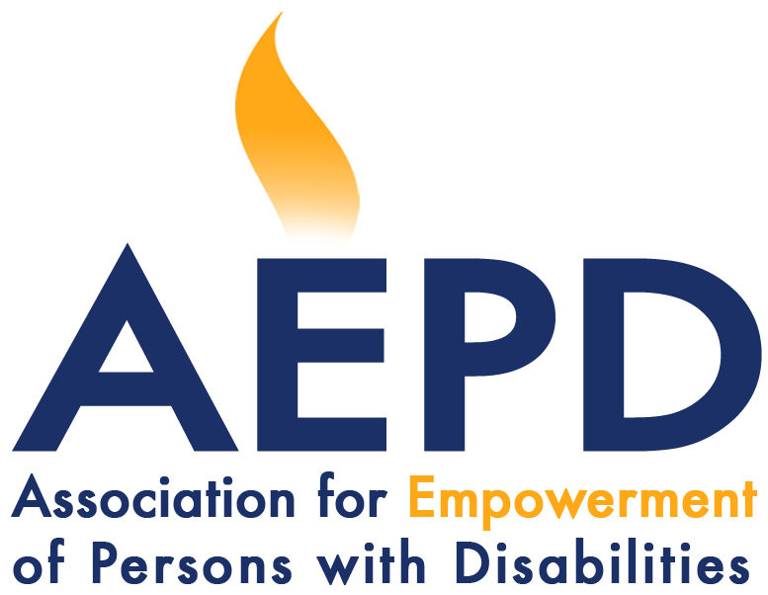

UBND TỈNH QUẢNG BÌNH
SỞ LAO ĐỘNG TB&XH

WORKSHOP
Promoting clearance and victim assitance integrated in socio-economic development of the province

Địa điểm: Tân Bình hotel, 04 Le Van Huu, Dong Hoi city
Thời gian: 26/10-/2012 – Started at 8h:00 AM

Time | Activities | Person responsible
8h - 8h5 | Introduction of workshop, participants, agenda | AEPD
8h5 - 8h15 | Opening | Provincial People’s Committee
8h15 - 8h35 | Landmine, cluster munition, uxo contaiminated situation of Quang Binh and its impacts on the lives of Quang Binh people.  (Question and answers) | Provincial Military Department
8h35 - 8h50 | Socio-Economic Development Plan of the province  (Question and answers) | Department of Planning and Investment
8h50-9h35 | Clearance and socio-economic development.  (Question and answers) | NPA
9h35 – 9h45 | Victim assistance  (Question and answers) | AEPD
9h45 – 10h00 | Tea break
10h00 -10h15 | Introduction of the main contents of the national program on action for recovering the consequences of landmine/UXOs under the Decision No.504/QĐ-TTg dated 21/04/2010 and priorities for the central region in general and for Quang Binh in particular.  (Question and answers) | VBMAC
10h15 - 10h30 | Sharing on integration of clearance, victim assistance in socio-economic development of Quang Tri  (Question and answers) | Quang Tri Military Department
10h30 – 11h30 | Plenary discussion on integration of clearance, vicitim assistance in socio-economic development of Quang Binh. Opinions, recommendations | AEPD/Consultant/Plenary
11h30 - 11h50 | Combination of opinions, sugessions, recommendations | Consultant
11h50 - 12h00 | Conclusion | Consultant/NPA

