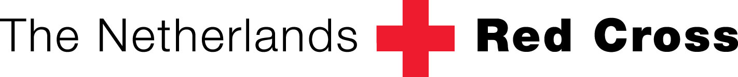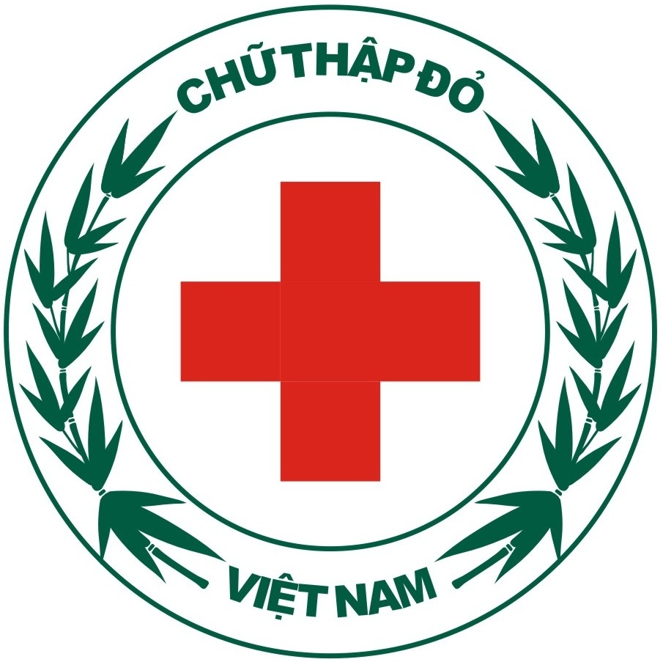

TERMS OF REFERENCE

General Information

Title: | Service Provider on Micro Finance.
Type of Contract | Special Service Agreement
Location: | Quang Binh province ( with 3 communes: Son Loc, Ly Trach, Nhan Trach)  and Quang Tri province ( with 3 communes (Trieu Phuoc, Trieu Long,  Trieu Hoa)
Desirable Starting Date | ASAP after contracting

Background:
The project Building safer and economically more resilient communities in Quang Binh and Quang Tri funded by the Rabobank Foundation is a programme implemented by Vietnam Red Cross and the Netherlands Red Cross. One of the expected results of the programme is that the communes in Quang Binh and Quang Tri have economic strength to prevent the impact of disasters and to recover quicker from disasters.

Vulnerability and poverty go together in a vicious circle: vulnerability to disasters is considerably increased by poverty and poor health, while at the same time disasters themselves throw people deeper into poverty. Besides the risk of losing their lives, people face the loss of personal assets, business capital and business places. After a disaster the economic infrastructure is often heavily damaged or even destroyed which means that people have no sources of income. In order to become more resilient to disasters the concept of Micro Finance is considered very relevant to Vietnam. The opportunity of micro finance is realized as a risk reduction tool, directly addressing the economical poor situation of the people in the selected communes. Micro finance is not only about access to loans, but also access to a safe place for savings and access to insurance. One crucial element is to address the willingness of the people to take a loan and to stimulate the poor to work on their situation themselves taking use of existing possibilities. It will focus on stimulation MF behavior and support with training on several relevant topic. This project will actually not offer these MF services themselves or set up any new Microfinance Institutions, but aims to link the target population to existing institutions.

Problem statement
In the first year of the project, 12 Self Help Groups (SHGs) in 6 the abovementioned communes were established and received training on necessary elements of MF. Next to that the groups are motivated to work on their economic and livelihood situation. The SHG also were helped to understand the criteria of certain organizations that can offer loans (e.g. PCF and Agribank). The results with regard to knowledge and motivation are good in all of the 12 SHGs. As the projects will not set-up any parallel system on micro-finance the members of the SHG are supposed to access MF products through existing institutions. To date this has not been succesful. Reasons as shared by SHG members were that they could not meet the requirements of these institutions, but at the moment it is not fully clear whether this difficulty is a perceived difficulty of whether they can really not obtain the MF services due to regulations and / or necessary collateral.

Scope of work:
In order to get the full and clear picture of the situation in these 6 communes the project is looking for a consultant to carry out the following tasks:
- Task 1: Give per commune (6 in total) a complete overview of the available MF options (including their products) that are present in each of the communes.
- Task 2: Give a detailed full overview of the criteria and conditions for each of the MF options in these communes have.
- Task 3: With the information of task 1 and 2, match the situation of the SHG members with the requirements as mentioned in task 2 to identify the bottlenecks that make it difficult for them to access the MF options.
- Task 4: After task 1, 2 and 3 are completed a clear picture about feasible MF options for the SHG member will be available. The goal of task 4 is to set a number of succesfullexample households in each SHG by coaching some members per SHG (approx 2 per SHG) in obtaining MF products within the available MF options in their commune. This can start with helping the SHG member to correctly complete the necesary forms up to helping them to develop a business plan. If some members of the SHG are succesful it will reduce the perception that it is difficult to access loans will then also be reduced, leading to more SHG members applying for loans.

Location:
- Quang Binh: 3 communes: Son Loc, Ly Trach, Nhan Trach
- Quang Tri: 3 communes: Trieu Phuoc, Trieu Long, Trieu Hoa

Start date: As soon as possible
End date: flexible

Deliverables:
Task 1,2 and 3:
1. Detailed workplan developed in consultation with NLRC and VNRC
2. Detailed report per commune covering task 1, 2 and 3

Task 4 (to be developed after completion of task 1, 2 and 3):
1. Work plan per SHG developed in consultation with NLRC, VNRC staff.
2. At least 1-2 identified members per SHG has taken loans from the identified MF institutions. In case of failure a clear explanation on the reasons and the process followed will be provided.

CONSULTANTS MAY APPLY FOR TASK 1,2,3 COMBINED AND TASK 4 SEPERATELY, BUT PREFERENCE WILL BE GIVEN TO A PARTY THAT CAN DELIVER ALL 4 TASKS.
Bids will be compared per task group. Consultants offering for all tasks can be recruited to carry out one of the tasks.

Qualifications:
Those applying to work as a service provider are expected to demonstrate experience of undertaking similar assignments in the past. Experience of succesful similar assignments undertaken in the past would be given preference. The expected qualifications of the consultant(s) are as follows:
- At least 5 years of working experience in a relevant field of Micro finance at field level;
- Being able to cross-check statements and not taking things for granted without proper explanation / justification.
- Understanding the MF climate in Vietnam and on existing MF schemes.
- Demonstrated experience in working with low income people, rural households showing an attitude of trustbuilding and equality.
- Possessing coaching behaviour, rather than trainers behaviour.
- Practical attitude focussing on finding solutions by coaching households on dealing with bureaucratic procedures.

Expectation for the application
Applicants will submit their detailed proposals to NLRC. The proposals will include the following information:
- Applicants will submit a detailed plan with time frame include working day in the field, preparation days and time needed for reporting.
- CVs of the actual consultants highlighting similar experiences in the past.
- The projects cost norm will be followed for accommodation, travel and perdiem, therefore the budget should include professional fees only, preferably specified per task. Please include PIT or VAT in the proposal.
Note: No administration fee can be included

Procedure
Interested consultants must provide information in English to: admin@nlrc.org.vn
Closing date for applications: Friday, 30 November 2012
Only short-listed candidates will be notified.

Consultants may associate to enhance their qualifications. The selection of consultants will be based on the value for money principle (such as best quality of the services, shortest delivery, best payment and delivery conditions, best price, experienced and reliable consultant). The candidate are informed that the contract will have to include provisions to ensure the consultants obligation towards non-exploitation of child labour, weapons, mines and the respect of basic social rights. Next to that it should be noted that the contract will also include the condition that the consultants should allow auditors or duly authorised agents to conduct any inspections on the suppliers bidding, contractual and other supporting documents relating to the implementation of this consultancy.

