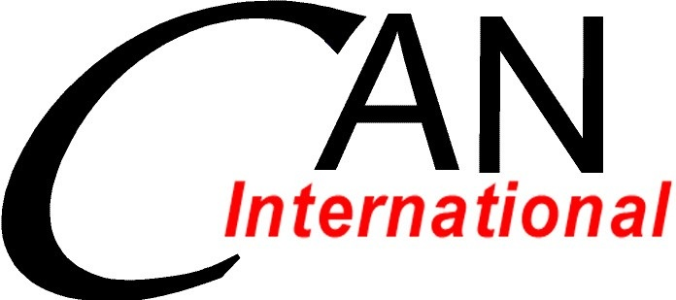

Climate Action Network - International
Leadership Development Program 2012

1. Introduction

Climate Action Network – International (CAN) is organizing a new program that aims at developing CAN leaders in CAN regional networks (nodes) especially from developing countries. Individuals, or “fellows,” selected for the Leadership Development Program will be undergoing a one-year program that includes attending the UNFCCC sessions, participating in workshops, and undergoing trainings. In addition, the selected fellows will implement a work plan within their own nodes during the program period. This work plan will be agreed among CAN, the respective node, and the candidate.

The first batch of fellows for this program will be developed for the period extending from November 2012, till the end of 2013. After graduation from this program, fellows are expected to remain active within their node, and the CAN Secretariat will continue to provide opportunities for the Alumni to engage the work of the Network whenever possible.

2. Application Submission

Submit completed applications by Monday, 17 September 2012 (GMT 12:00 pm) by email to participation@climatenetwork.org. Successful applicants will be notified by Friday 19th October 2012.

Selected fellows will have to develop in cooperation with his/her respective node and the CAN Secretariat a work plan to implement during the Leadership Development Program period by 5th November 2012.

3. Terms of Application

Leadership development participants are expected to participate in all and entire UNFCCC sessions as invited by CAN and commit to an agreed program developed for their support. The following terms will be strictly adhered to:

- Only complete applications will be considered;

- Only direct staff/active members of CAN member organizations or organizations already in the process of becoming a member are eligible for the Fellowships;

- Applicants will be selected by a small panel of the CAN Secretariat and the Board of Directors after consultation with the regional coordinators; and

- Priority will be given to under-represented geographic regions in the UN climate negotiations, highly motivated individuals, and those willing to be an active member in his/her regional node.
4. Criteria for Selection

- Be staff/active member of a CAN member organization or an organization in the process of becoming a CAN member;
- Demonstrate proven leadership and coordination;
- Demonstrate they have learning attitudes and willing ness to devote time with interest on climate policy at different levels: national, regional and international;
- Posses a good understanding of climate change issues and have experience working in the area for at least two years;
- Have experience working with NGOs and networks;
- Have the support of their organization to participate as a Fellow with CAN and to have an ongoing relationship with CAN;
- Be able to attend leadership development program designed by CAN, such as interact with media, attend negotiations, participate in a Pre-COP workshop, etc:
- Possess a strong ability to communicate, written and verbal, in English;
- Be interested in playing a role within civil society, rather than within a government delegation;
- Be involved in or be willing to join one of CAN’s thematic working groups (adaptation, mitigation, finance, etc.);
- Contribute to CAN discussions, and participate in CAN activities, such as publications (ECO), blogs, drafting and delivering interventions, press conferences, Fossil of the Day, etc;
- Attend all CAN events at the negotiations including, but not limited to: capacity building and strategy sessions, daily check-ins with program liaison, meetings with government delegations, meetings with experts organized by the program liaison;
- Be able to actively work in coordination with the regional coordinator during the negotiations and between the sessions to support national and regional activities – sharing information, writing blogs, being a resource person, etc.;
- Agree to sign individual contracts that outline their responsibilities with CAN and will be held accountable to the requirements in the agreement;
- Higher priority will be given to those who show keen interest in co-financing their participation; therefore, we encourage participants to fundraise or seek co-financing;
- Have access to financing to purchase plane tickets and other expenses before conferences (expenses are only reimbursable AFTER the sessions are complete).

5. Application Form

Please complete all fields (A and B) below and provide attachments in section C. All information will only be used for the selection of 2012 CAN Leadership Development Fellows.

A. Personal Information:

TITLE: | Mr./Miss/Ms./Mrs.
NAME:
ORGANISATION:
POSITION:
EMAIL:
COUNTRY:
REGIONAL NODE:

B. Qualifications:
Please answer the following 12 questions in complete sentences or bullet points. Please limit each answer to no more than 250 words.

1 | CAN member: Is your organization a CAN member? If yes, please describe your organization’s previous involvement in CAN activities and its projects and collaborations with other CAN members in your region.  Answer:
2 | Explain your role in the successful or challenging projects/work your organization (or former organization) has performed. Answer should be focused on leadership and coordination you provided during this project. Also identify any coordination roles/tasks you’ve played in the past.  Answer:
3 | Explain your knowledge of international climate change issues.  (Describe your previous engagement on international climate change issues and the UNFCCC. Have you participated in any of the climate negotiations? If yes, briefly describe how you participated and contributed. If no, explain how you would expect to contribute at the negotiations with CAN and for your region)  Answer:
4 | Explain your knowledge of climate change and NGO activities in your region to address the crisis. Describe your involvement with other NGOs as well as civil society networks or coalitions.  Answer:
5 | What are your plans for the future? How long are you planning to stay engaged in CAN? And how will you use the knowledge gained through this leadership development program?  Answer:
6 | Can you attend the UNFCCC sessions (Qatar COP and all sessions in 2013?), a Pre-COP workshop at the end of November as well as any potential future training/event assigned for the training? Please list any dates between Nov 2012 -December 2013 that you would not be able to participate in CAN travel activities. Explain how you will attend and contribute to all of these activities during these UNFCCC sessions as well as perform the work your organization will require of you during the sessions?  Answer:
7 | Describe how you will contribute to CAN and your region’s NGO climate change activities during and between the UN negotiation sessions. If there is a CAN regional network in your region, explain how your work will feed-into the Network’s activities.  Answer:
8 | You are expected to regularly follow one or maximum two issues at the UN sessions. CAN has several issue based working groups (e.g. adaptation, mitigation, legal, technology transfer, finance, etc.) What is your interest area or priority and why? How do you see yourself contributing to these groups?  Answer:
9 | CAN hosts policy and strategy discussions, and shares its messages through publications -- like ECO, blogs, UNFCCC interventions, press conferences, and the Fossil of the Day award. What is your experience participating in policy and strategy discussions with a network? What is your experience participating in publication creation, blog writing, presentations, and press conferences.  Answer:
10 | Will you be able to co-finance or fundraise for your participation if you were selected? Outline how you will finance (either personally or through your organization) your expenses (for up to two months) before they will be reimbursed by CAN for each UN session, workshop and training.  Answer:

C. Attachments:

Please attach the following documents to your application:
- Cover letter stating how you meet the Fellowship requirements.
- Current resume or CV.
- Letter of support from your organization stating how your organization will support your participation (scanned version or pdf). This letter must include the duties you will be expected to perform for your organization while at the UN negotiations and be signed by the head of the organization.
- Links to media interviews, video blogs, or examples of media work you have done. Please provide two examples, if possible, preferably including one in English.

