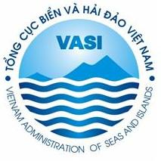

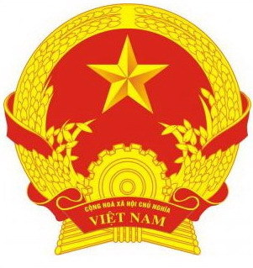

MINISTRY OF NATURAL RESOURCES AND ENVIRONMENT
VIETNAM ADMINISTRATION OF SEAS AND ISLANDS

HAI PHONG PEOPLE’S COMMITTEE

REGISTRATION FORM
“The 1st Forum and Exhibition on Technologies
for the Development of Vietnam’s Sea Economy ”

Time: May 07th – 08th, 2013
Location: Hai Phong Conference Centre, 18 Hoang Dieu, Hong Bang, Hai Phong

Name of organization:……………………………………………….………………………………….….….
Address:………………………………………………………………………………………………...……..…………….
Website:……………………………………………………….………………………………………………..
Contact person:………………………………………………………………………………………………..
Email:……………………………………………………………………………………………….…..………

Name of participants | Function | Mobile and Email
1.Mr./Ms.:
2. Mr./Ms.:
3. Mr./Ms.:
4. Mr./Ms.:

Please fill in this form and send to the Organizing Committee before May 03rd, 2013 via email: bichlien@megainvest.vn and info@megainvest.vn or contact Ms. Lien Tel: ++ 84 4 35123198/ (+84) 989082765 or Mr. Thao (+84)989136666.

Thank you!

