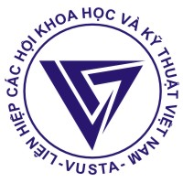
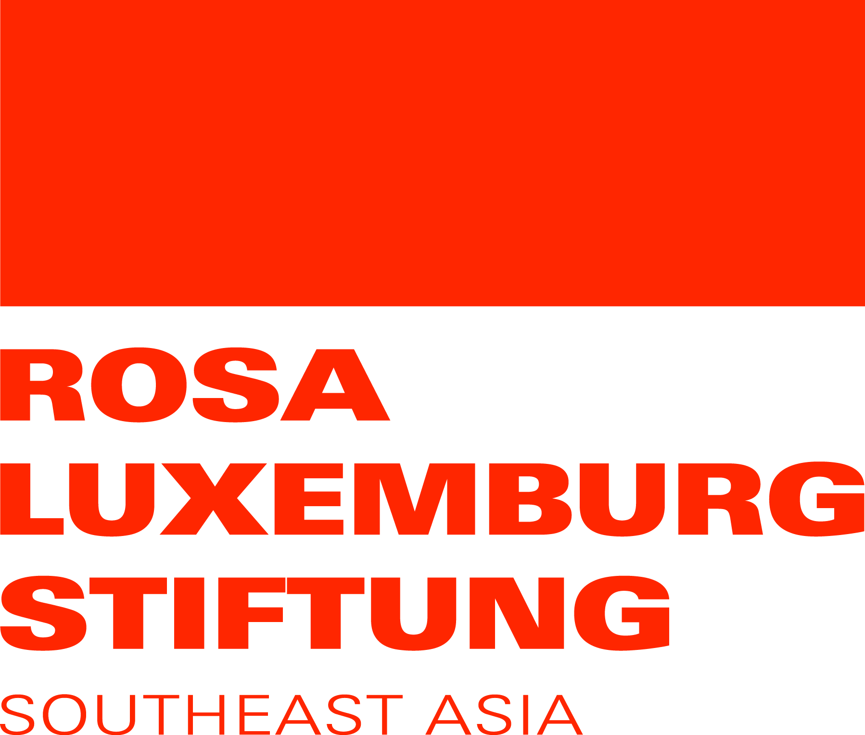
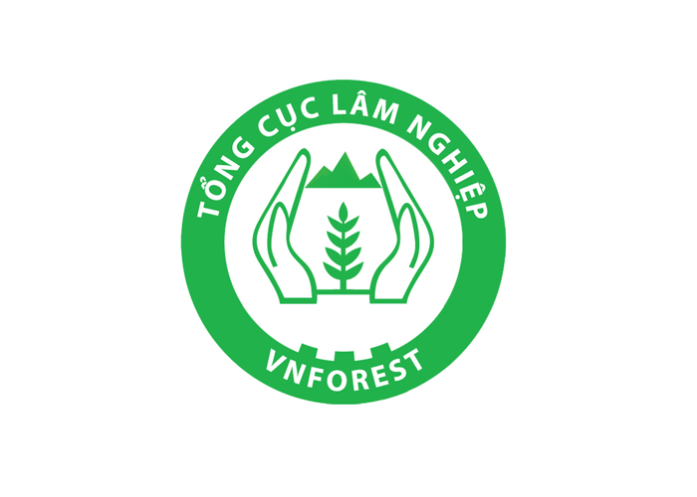


WORKSHOP ANNOUNCEMENT

SHARING EXPERIENCE ON THE RIGHTS AND RESPONSIBILITIES OF ETHNIC MINORITY COMMUNITIES IN NATURAL FOREST MANAGEMENT

- Introduction

Community forests have existed as part of local traditions and life. They align the interests of people with the spiritual and religious beliefs of the community and play a crucial role in the livelihoods and culture of ethnic minority groups. To promote the interests of the community and their role in forest sustainability, the Vietnamese state has been allocating forests to the community for long-term management and use since the 1990s.

In order to create significant change in the current structure of forest management there needs to be increasing support for local people to access rights to land and forests, as well as promotion of the strengths of community based forest management. There needs to be a strong commitment from local and national authorities, and the distribution of necessary resources in order to ensure that the new policies will be effectively implemented at all the different levels.

Since 2011, with sponsorship from Rosa Luxemburg Stiftung in Southeast Asia, C&E Center and partners in Thua Thien Hue and Quang Nam provinces have been executing a pilot project: “Sustainable management of natural forest through raising awareness and building capacity to improve the rights and legal status of ethnic minority communities to natural forest in central Vietnam (2012-2014)”. The pilot phase has shown that an effective sustainable forest management model can support local communities in using all their rights while maintaining livelihoods and developing their cultures. The project can be duplicated in other remote areas with larger natural forests and higher rates of impoverished families.

To support and motivate communities to effectively use, develop and protect forest resources as well as contribute to forestry reformation and exchange; Center for Development of Community Initiative and Environment (C&E) along with VUSTA (Vietnam Union of Science and Technology Associations) and Vietnam Administration of Forestry are organizing a workshop: “Sharing experience on the rights and responsibilities of ethnic minority communities in natural forest management”. The workshop will be held on October 24th 2014 in Hanoi. The workshop is sponsored by Rosa Luxemburg Stiftung, Southeast Asia Office.

- Objective of the workshop
- To share results and lessons learnt from experiences empowering the use of ethnic minorities’ rights and responsibilities in natural forest management.
- To propose solutions to support the use of ethnic minority communities’ rights and responsibilities in natural forest management in the future

- Content of the workshop
- Building the capacity for ethnic minority communities to use their rights and responsibilities in natural forest management.
- Supporting stakeholders at different levels to use ethnic minority communities’ rights and responsibilities in natural forest management.
- The role and coordination of different stakeholders in supporting the use of ethnic minority communities’ rights and responsibilities in natural forest management.
- Discussion on finding solutions to support the use of ethnic minority communities’ rights and responsibilities in natural forest management in the future

- Time and venue: 24/10/2014 in Hanoi

- Participants: about 70 people, including:
- Representatives of local authorities and local people in 2 provinces that have project site of C&E
- Government organizations in related fields.
- Local non-governmental organizations and scientists working in related fields.
- Representatives of communities with effective natural forest management models in the North, South and Highland of Vietnam
- Media.

- The organizing committee: including leaders of the following partners:
- VUSTA (Vietnam Union of Science and Technology Associations)
- Vietnam Administration of Forestry
- Center for Development of Community Initiative and Environment (C&E)

- How to participate
Step 1 - Registration: organizations and individuals who want to participate in the conference will need to send the application forms attached to this announcement to the organizing committee via Email or post office before 20/10/2014.
Step 2 - Sharing experiences presentation: registered delegates will need to send a short presentation (not exceeding 7 pages) to the organizing committee (following the direction file attached with this announcement) before 20/10/2014.

The organizing committee sincerely invites local provinces that have effective community forest management models, local authorities, organizations, and scientists working in related fields to contribute presentations and participate in the conference.

On behalf of the organizing committee

MSc. Hoang Thanh Tam
Note:
- The organizing committee will prioritize delegates that have been or are doing activities, reports about experiences related to the conference content.
- The organizing committee will provide travel cost, accommodation and honorarium for delegates from Vietnamese organizations that have presentations chosen to be shared at the conference
- Posters, banners, reports, guidelines… are encouraged to be shown in the conference.

Contact Information:

Center for Development of Community Initiative and Environment (C&E)
No 12, Lane 89, Xa Dan Street, Dong Da District, Hanoi
Phone: 043 573 8536, 0912234782; 091 2371366; 0904312661

Email: ce.center.office@gmail.com

